Exercise 2: SQL Aggregate functions and Operators
Nandipha Dondashe
Data Analytics
BrightLearn
07 September 2026
2805002580

- List all distinct departments in the students table (expected columns: department)
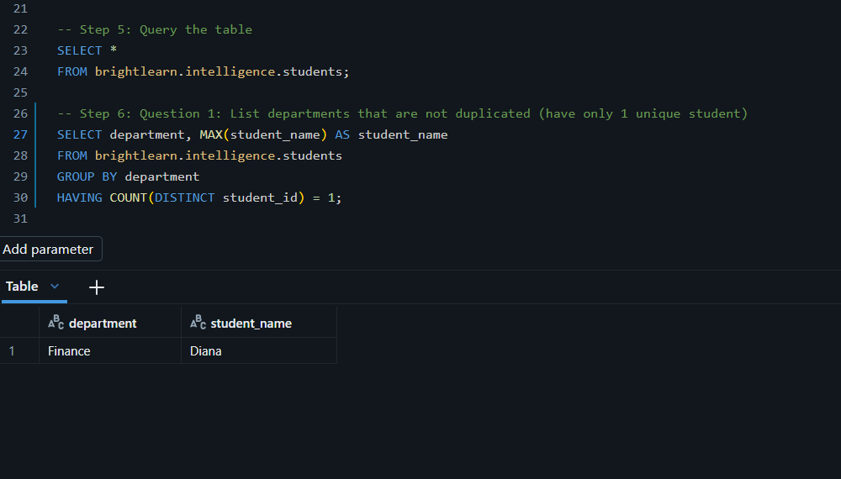
- Get the average age of students per department (expected columns: department & average age)
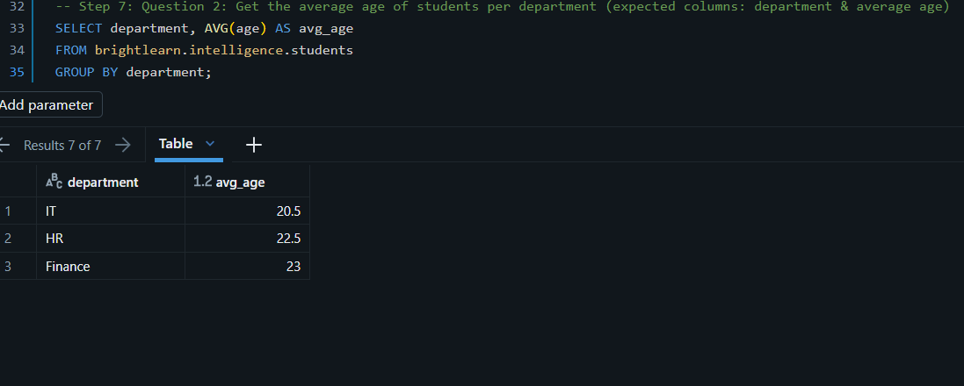

- Show departments with more than one student (expected columns: department, student account)

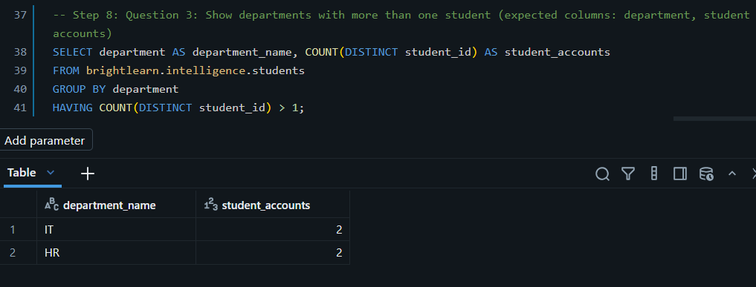

- Get all students whose age is between 21 and 23 (expected columns: student_id, name, age, department)
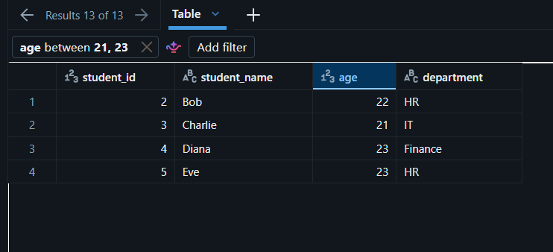

- List all students in the IT or HR department who are older than 21years (expected columns: student_id, name, age, department)
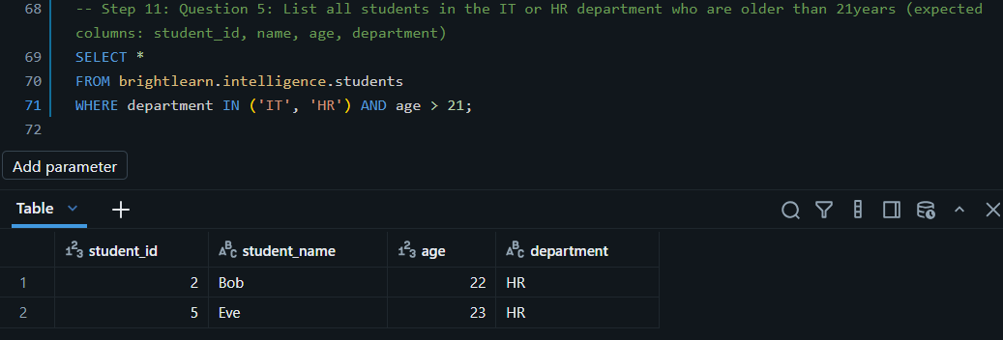

- Show total credits per department, only for departments with more than 5 total credits (expected columns: department, total credits)

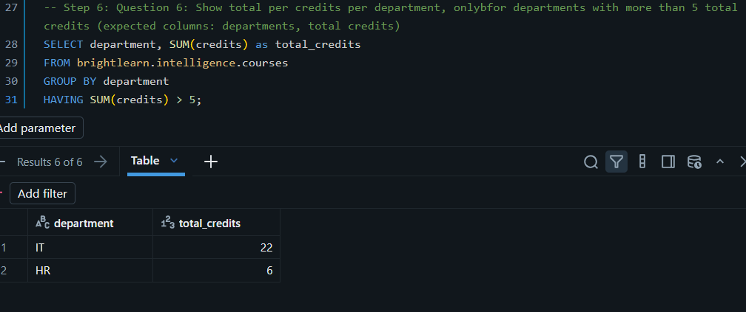

- List all courses that do not have 4 credits (expected columns: course_id, course_name, department, credits)

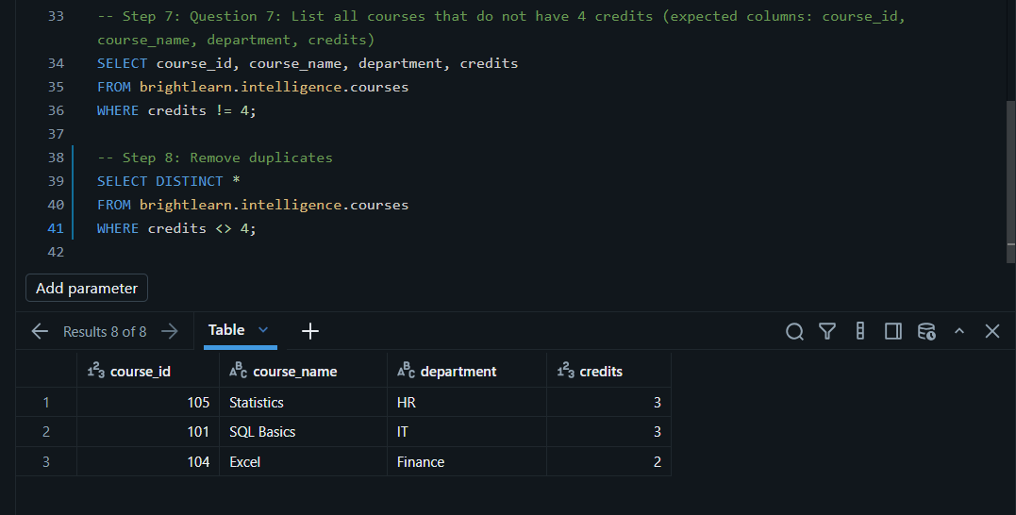

- Show the top 3 courses by credits in descending order (expected columns: course_id, course_name, credits)

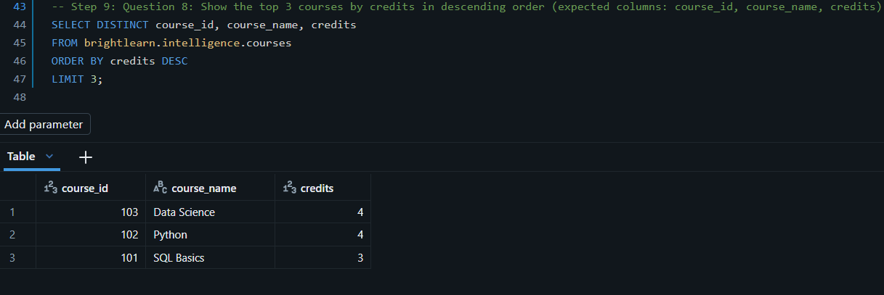

- Get the maximum, minimum, and average grade across all enrolments (expected columns: max_grade, min_grade, avg_grade)

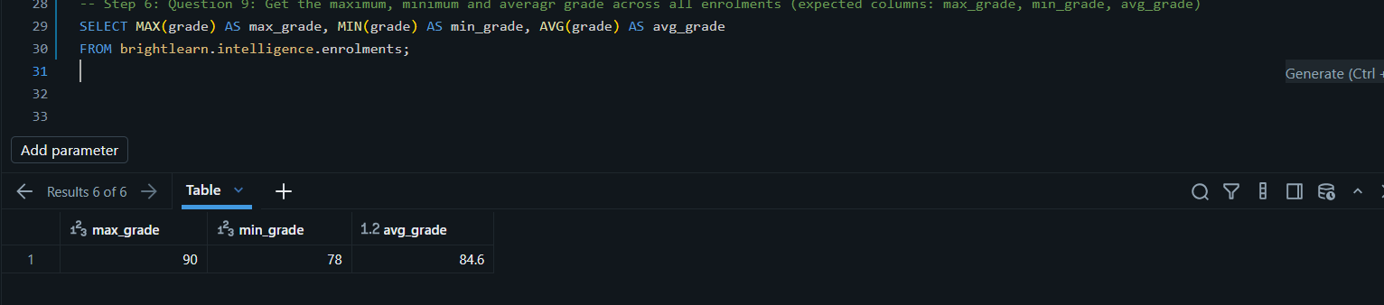

- Count how many enrolments exist per course (expected columns: course_id, enrolment_count)

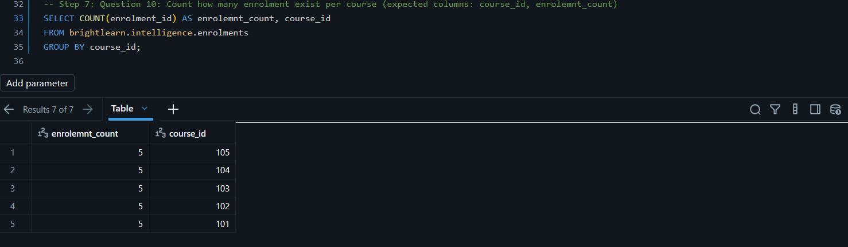

- Find total salary and total bonus per department (expected columns: department, total_salary, total_bonus)

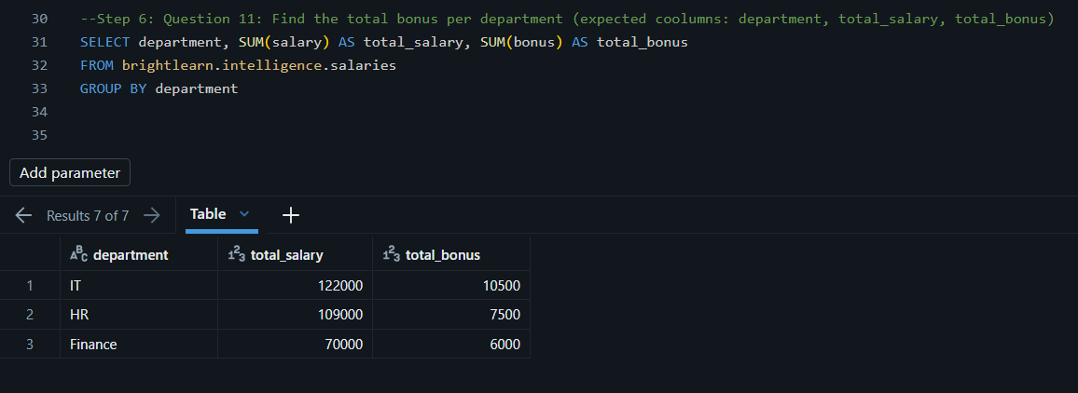

- Show departments where average salary is above R55 000(expected columns: department, avg_salary)

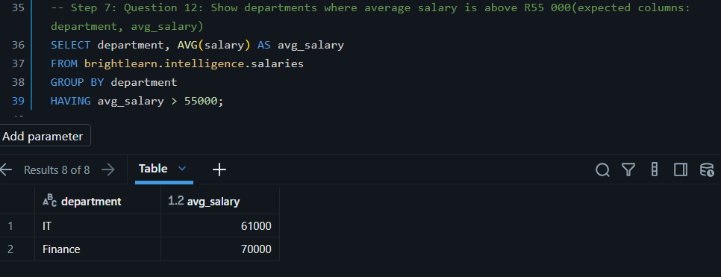

- List employees whose salary plus bonus is greater than R60 000(expected columns: employee_id, name, salary, bonus, total_compensation)

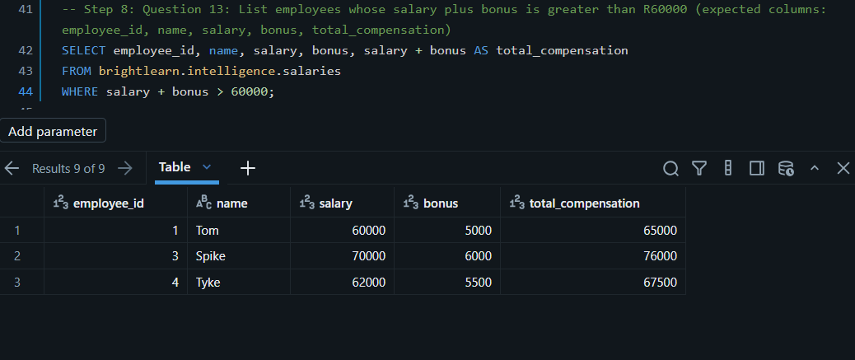
- Show total and average budget per department. Only include departments with average budget above R70 000 (expected columns: department, total_budget, avg_budget)

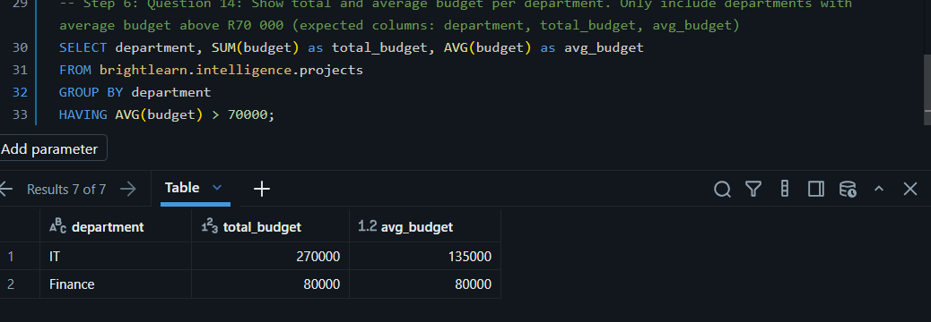

- List all projects with budgets between R50 000 and R120 000, excluding the Marketing department (expected columns: project_id, project_name, department, budget)

